ER Relationship Diagram

Objective
The objective of this submission is to update the ER diagram by including the Seller and Inventory entities and defining their relationships with the Product entity in the ShopEase system.
Entities
The updated ER diagram contains the Seller, Inventory, and Product entities.
Seller
The Seller entity stores the details of suppliers who provide products.
Attributes:
- Seller_ID – Primary Key
- Seller_Name
- Phone
- Email
- Address
Inventory
The Inventory entity stores the stock details of products supplied by sellers.
Attributes:
- Inventory_ID – Primary Key
- Product_ID – Foreign Key
- Seller_ID – Foreign Key
- Quantity
- Last_Updated
Product
The Product entity stores the details of products available in the system.

Attributes:
- Product_ID – Primary Key
- Product_Name
- Category_ID – Foreign Key
- Price
Relationships
Seller – Inventory
Relationship: One-to-Many (1:M)
One seller can manage multiple inventory records, while each inventory record belongs to one seller.
Inventory – Product
Relationship: Many-to-One (M:1)
Multiple inventory records can refer to a product, while each inventory record is associated with one product.
ER Diagram – Seller, Inventory and Product
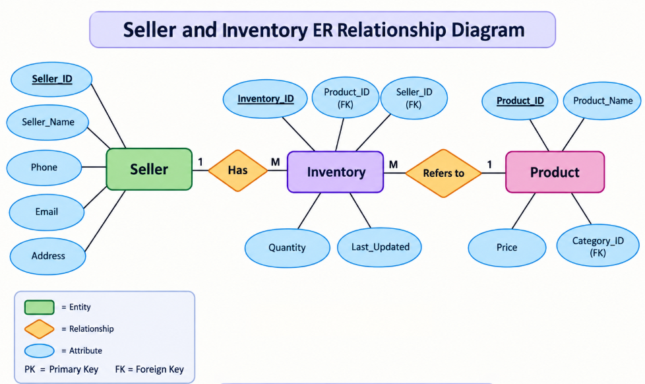

Key Identification
- PK represents Primary Key.
- FK represents Foreign Key.
- 1:M represents One-to-Many relationship.
- M:1 represents Many-to-One relationship.
Result
The ER relationship diagram was successfully updated to represent Seller, Inventory, and Product entities. Primary keys, foreign keys, attributes, and relationship cardinalities are clearly represented.

